Film Fest

1.0 Introduction
1.1 Functional Requirements
FilmFest is the Cinematic Celebration and Showcase Platform app, which is designed for emerging film makers to showcase their talent and gain recognition within the industry. The organizing committee approached you to create an application to manage the festival details and the film details showcased by various directors.
You need to implement the Fest and Film module of the online Film Fest Application. The client wishes to have restful web services to add a new Fest, modify the details of the Fest, and view the Fest details based on the requirement. Also, the client wishes to have restful web services for manipulation of Film like adding Film, modifying Film details, and viewing the Film details based on the requirement. Help them automate the above process by developing a Rest Service using Maven.
2.0 Technical Specifications
The provided FestController and FilmController, which are RestController, should be created with the given services:
Services:
FestController:
All the below endpoints should return the ResponseEntity
- For success - HttpStatus.OK
Request Method | Request Url | Description
Post | /addFest | This service should add the Fest details by using the addFest method of the FestServiceImpl.
Put | /updateEnrollmentFee/{festId}/{enrollmentFee} | This service should retrieve the existing Fest details for the given festId and update the enrollmentFee by using the updateEnrollmentFee method of the FestServiceImpl.
Get | /viewFestById/{festId} | This service should retrieve the Fest details for the given festId using the viewFestById of FestServiceImpl.
Get | /viewFestsWithVisitors/{visitorsCount} | This service should retrieve all the Fest details with a visitorsCount equal to or exceeding the given visitorsCount by using the viewFestsWithVisitors method of FestServiceImpl.
Get | /getFilmCountFestwise | This service should retrieve the total count of films in each fest by using the getFilmCountFestwise method of the FestServiceImpl.

FilmController:
All the below endpoints should return the ResponseEntity
- For success - HttpStatus.OK
Request Method | Request Url | Description
Post | /enrollFilm/{festId} | This service takes the Film object and the festId of the Fest object as input, and it should add the Film details by using the enrollFilm method of the FilmServiceImpl.  Note: The Film object holds details like filmId, filmName, genre, director, year, and duration.
Put | /updateDuration/{filmId}/{duration} | This service should retrieve the existing Film details for the given filmId and update the duration by using the updateDuration method of the FilmServiceImpl.
Get | /viewFilmsByFest/{festName} | This service should retrieve all the existing Film details for the given festName by using the viewFilmsByFest method of the FilmServiceImpl.
Get | /viewFilmsByYearAndGenre/{year}/{genre} | This service should retrieve all the existing Film details with the given year and genre attributes by using the viewFilmsByYearAndGenre method of the FilmServiceImpl.
Delete | /deleteFilm/{filmId} | This service should delete an existing Film detail by using the deleteFilm method of the FilmServiceImpl.

Service Layer
The provided code skeleton includes the IFestService and IFilmService interfaces. The FestServiceImpl and FilmServiceImpl classes in the code skeleton must implement all the methods defined in the IFestService and IFilmService interfaces, respectively.

In the FestServiceImpl and FilmServiceImpl classes, all database-related operations should be implemented using the FestRepository and FilmRepository interfaces, respectively.

Methods in FestServiceImpl
Method in Service | Description | Exception
addFest | This method accepts the Fest object, which holds details like festId, festName, venue, enrollmentFee, ticketCost, and visitorsCount.  Also, add the Fest details to the database using FestRepository and return the Fest object.
updateEnrollmentFee | This method accepts festId and enrollmentFee as arguments. It should check the availability of the Fest based on the festId, update the enrollmentFee with the existing enrollmentFee of that Fest object in the database using FestRepository, and return that Fest object. | If no Fest exists with that festId, then throw an InvalidFestException.
viewFestById | This method accepts festId as an argument. It should retrieve the Fest with the festId passed as a parameter. | If no Fest exists with that festId, then throw an InvalidFestException.
viewFestsWithVisitors | This method accepts visitorsCount as an argument. It should retrieve the list of Fest details with the visitorsCount equal to or exceeding the visitorsCount passed as a parameter.
getFilmCountFestwise | This method retrieves the total count of films in each fest from the database and returns a Map with a key as filmId and a value as the total count of all films in that fest.

Methods in FilmServiceImpl
Method in Service | Description | Exception
enrollFilm | This method accepts a Film object that holds details like the filmId, filmName, duration, genre, director, year, and festId. This method should retrieve the Fest object for the fest id passed as a parameter.  Next, set that Fest object to the Film object. Add the Film details to the database using FilmRepository and return the Film object. | If no Fest exists with that festId, then throw an InvalidFestException.
updateDuration | This method accepts filmId and duration as parameters. It should check the availability of the Film based on the filmId, update the duration of that Film object in the database using FilmRepository, and return that Film object. | If no Film exists with that filmId then throw an InvalidFilmException
viewFilmsByFest | This method accepts the festName as an argument. It should retrieve the list of Films from the database using FilmRepository, which belongs to the Fest with festName passed as a parameter.
viewFilmsByYearAndGenre | This method accepts the year and genre as arguments. It should retrieve the list of Film objects from the database using FilmRepository, whose year and genre were passed as parameters.
deleteFilm | This method accepts filmId as an argument. It should delete the Film details based on the filmId passed as a parameter and return that Film object. | If no Film exists with that filmId then throw an InvalidFilmException

Repository Layer
Refer to the FestRepository and FilmRepository interfaces provided as part of the code skeleton. Use appropriate Spring Data JPA for all the database-related manipulation.
Also, include the necessary methods to view Fest by id, view Fests by visitorsCount, and view Film count based on each Fest in FestRepository, and include the necessary methods to view Films by festName and view Films by year and genre in the FilmRepository interface.
Model
Refer to the Model classes provided as part of the class diagram/code skeleton and use appropriate annotations for the persistence mapping in the model class.
Note that one Fest object is related to multiple Film objects, and one Film object will be related to one Fest object.

Model Class
Refer to the Fest and Film class provided as part of the code skeleton, use appropriate annotations to generate a getter/setter and an all-argument constructor.
Fest class
Attribute | Data Type
festId | int
festName | String
venue | String
enrollmentFee | double
ticketCost | double
visitorsCount | int
filmList | List<Film>

Film class
Attribute | Data Type
filmId | int
filmName | String
duration | int
genre | String
director | String
year | int
festObj | Fest

Note:
- Use Lombok to generate getters and setters for the attributes
- Also generate all-argument constructor using lombok
- Do not change the datatype or the attribute name provided as part of the code skeleton
- Id field should not be auto generated

Business Validation
Inbuilt Validation
Fest class
Rule | Message when validation fails
festId should be greater than 0 | Fest id should be a positive integer
festName should not be empty | Provide value for fest name
venue should not be empty | Provide value for venue
enrollmentFee should be greater than zero | Enrollment fee should be greater than zero
ticketCost should be greater than zero | Ticket cost should be greater than zero
visitorsCount should be greater than zero | Visitors count should be greater than zero

Film class
Rule | Message when validation fails
filmId should be greater than zero | Film Id should be a positive integer
filmName should not be empty | Provide value for Film name
duration should be between 100 and 150 | Duration should be between 100 and 150
genre should not be empty | Provide value for Genre
director should not be empty | Provide value for Director
year should be greater than or equal to 2000 | Year should be greater than or equal to 2000

Perform the above Validations using annotations that are available in jakarta.validation.constraints package
Incorporate Exception and validations as ResponseEntity
To incorporate the messages related to Exception and validations (both custom and inbuilt validations) as ResponseEntity, you are provided with the following classes.
- ExceptionResponse class that represents what attributes needs to be there in the customized response error message. Make use of this class to send the customized response error message.
- CustomizedResponseEntityExceptionHandler class to handle all the exceptions that has occurred in the application (both user-defined and pre-defined).
Method Name | Explanation
handleAllExceptions | This method should generally handle all the exceptions.  In ResponseEntity set the HTTPStatus as INTERNAL_SERVER_ERROR.
handleNotFoundException | This method should handle and provide customized error message using Exception Response class for user defined exception InvalidFestException and InvalidFilmException.  In ResponseEntity set the HTTPStatus as NOT_FOUND.
handleMethodArgumentNotValid | This method should handle and provide customized error message using Exception Response class for both pre-defined and user defined validations.  In ResponseEntity set the HTTPStatus as BAD_REQUEST.

3.0 Expected Table Structure
The below table should get created automatically by the application
Note
- Provide the necessary annotation in the model classes so that the column size for String fields is set to 25 characters.
Fest
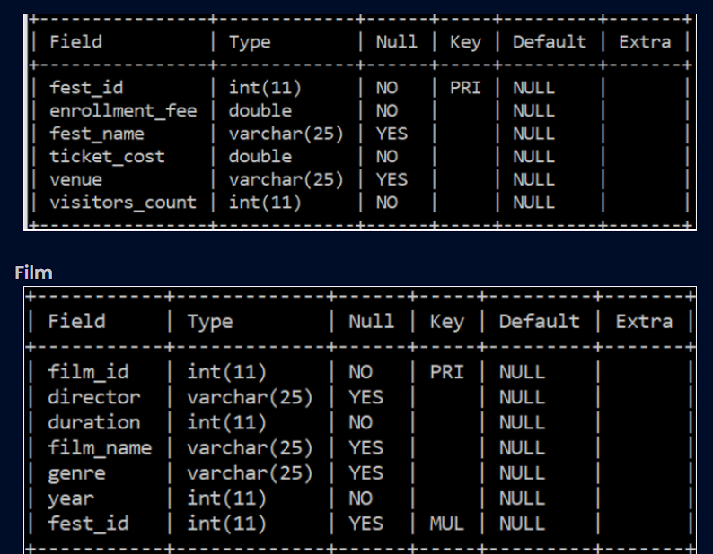

Note: fest_id is the join column in the Film table
4.0 Proces Flow
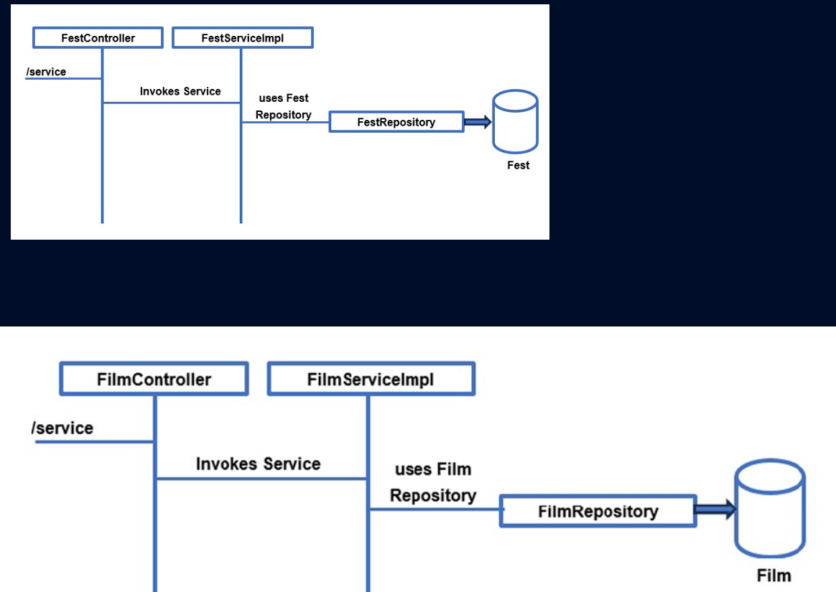
- Client invokes the required service.
- FestController invokes the method of the FestServiceImpl and FilmController invokes the method of the FilmServiceImpl.
- FestServiceImpl with the help of FestRepository performs the service and returns the data back.
- FilmServiceImpl with the help of FilmRepository performs the service and returns the data back.
- IFestService has to be injected into the FestController.
- FestRepository has to be injected into the FestServiceImpl.
- IFilmService has to be injected into the FilmController.
- FilmRepository has to be injected into the FilmServiceImpl.
- The FestRepository interface and FilmRepository interface should use the appropriate Spring Data JPA for all the database-related manipulation.

4.0 Overall Design Constraints
- Do not change the property and value given in the application.properties files. If needed you can change the value of username and password alone according to what you have in your MYSQL
- In the pom.xml you are provided with all the dependencies needed for developing the application.
- Use only Spring data JPA to handle persistence. Do not generate value for the primary key attribute automatically.
- Use the service type and the service names as expected in the specification
- Adhere to the design specifications mentioned in the case study.
- Do not change or delete the class/method names or return types which are provided to you as a part of the base code skeleton.
- Please make sure that your code does not have any compilation errors while submitting your case study solution.

Answer
=============

FilmFest/src/main/java/com/exception/ExceptionResponse.java
1 package com.exception;
2
3 import java.time.LocalDate;
4
5 import lombok.AllArgsConstructor;
6 import lombok.Data;
7 import lombok.Getter;
8 import lombok.Setter;
9 @Data
10 @Getter
11 @Setter
12 @AllArgsConstructor
13 public class ExceptionResponse {
14 private LocalDate timestamp;
15 private String message;
16 private String details;
17 private String httpCodeMessage;
18 }
19
FilmFest/src/main/java/com/service/FestServiceImpl.java
1 package com.service;
2
3 import java.util.List;
4 import java.util.Map;
5 import java.util.Optional;
6 import java.util.stream.Collectors;
7
8 import org.springframework.beans.factory.annotation.Autowired;
9 import org.springframework.stereotype.Service;
10
11 import com.entities.Fest;
12 import com.exception.InvalidFestException;
13 import com.repository.FestRepository;
14
15 //Provide necessary annotation
16 @Service
17 public class FestServiceImpl implements IFestService{
18
19 //Provide necessary annotation
20 @Autowired
21 private FestRepository festRepository;
22
23 public Fest addFest(Fest fest) {
24 return festRepository.save(fest);
25 }
26
27 public Fest updateEnrollmentFee(int festId,double enrollmentFee) throws InvalidFestException {
28 Optional<Fest> festOptional = festRepository.findById(festId);
29 if(festOptional.isPresent()) {
30 Fest festToUpdate = festOptional.get();
31 festToUpdate.setEnrollmentFee(enrollmentFee);
32 return festRepository.save(festToUpdate);
33 } else {
34 throw new InvalidFestException();
35 }
36 }
37
38 public Fest viewFestById(int festId) throws InvalidFestException {
39 Optional<Fest> festOptional = festRepository.findById(festId);
40 if (festOptional.isPresent()) {
41 return festOptional.get();
42 } else {
43 throw new InvalidFestException();
44 }
45 }
46
47 public List<Fest> viewFestsWithVisitors( int visitorsCount) {
48 return festRepository.findByVisitorsCountGreaterThanEqual(visitorsCount);
49 }
50
51 public Map<Integer,Integer> getFilmCountFestwise() {
52 List<Object[]> results = festRepository.getFilmCountFestwise();
53 return results.stream()
54 .collect(Collectors.toMap(
55 result -> (Integer) result[0],
56 result -> ((Number) result[1]).intValue()
57 ));
58 }
59
60 }
61
FilmFest/src/main/java/com/service/FilmServiceImpl.java
1 package com.service;
2
3 import java.util.List;
4 import java.util.Optional;
5
6 import org.springframework.beans.factory.annotation.Autowired;
7 import org.springframework.stereotype.Service;
8
9 import com.entities.Fest;
10 import com.entities.Film;
11 import com.exception.InvalidFestException;
12 import com.exception.InvalidFilmException;
13 import com.repository.FestRepository;
14 import com.repository.FilmRepository;
15
16 //Provide necessary annotation
17 @Service
18 public class FilmServiceImpl implements IFilmService{
19
20 //Provide necessary annotation
21 @Autowired
22 private FilmRepository filmRepository;
23
24 @Autowired
25 private FestRepository festRepository;
26
27 public Film enrollFilm( Film film, int festId) throws InvalidFestException {
28 Optional<Fest> festOptional = festRepository.findById(festId);
29 if (festOptional.isPresent()) {
30 film.setFestObj(festOptional.get());
31 return filmRepository.save(film);
32 } else {
33 throw new InvalidFestException();
34 }
35 }
36
37 public Film updateDuration(int filmId, int duration) throws InvalidFilmException{
38 Optional<Film> filmOptional = filmRepository.findById(filmId);
39 if(filmOptional.isPresent()) {
40 Film update = filmOptional.get();
41 update.setDuration(duration);
42 return filmRepository.save(update);
43 } else {
44 throw new InvalidFilmException();
45 }
46 }
47
48 public List<Film> viewFilmsByFest(String festName){
49 return filmRepository.findByFestObjFestName(festName);
50 }
51
52 public List<Film> viewFilmsByYearAndGenre( int year, String genre) {
53 return filmRepository.findByYearAndGenre(year, genre);
54 }
55
56 public Film deleteFilm(int filmId) throws InvalidFilmException {
57 Optional<Film> obj=null;
58 obj=filmRepository.findById(filmId);
59 if(obj.isPresent())
60 {
61 filmRepository.delete(obj.get());
62 return obj.get();
63 }
64 else
65 throw new InvalidFilmException();
66 }
67 }
FilmFest/src/main/resources/application.properties
1
2 #Do not change the property name, you can change the value if needed
3 spring.application.name=ELearningPlatform
4 server.port=7188
5 spring.datasource.driver-class-name=com.mysql.cj.jdbc.Driver
6 spring.jpa.properties.hibernate.dialect= org.hibernate.dialect.MySQL8Dialect
7 spring.datasource.url=jdbc:mysql://localhost:3306/test?createDatabaseIfNotExist=true
8 spring.datasource.username=root
9 spring.datasource.password=
10
11 spring.jpa.generate-ddl=true
12 spring.jpa.hibernate.ddl-auto=none
13
14 # Show or not log for each SQL query
15 spring.jpa.show-sql=true
16
17 # Allows Hibernate to generate SQL optimized for a particular DBMS
18 # spring.jpa.properties.hibernate.dialect=org.hibernate.dialect.MySQL8Dialect
19
FilmFest/src/main/java/com/controller/FestController.java
1 package com.controller;
2
3 import java.util.List;
4 import java.util.Map;
5
6 import org.springframework.beans.factory.annotation.Autowired;
7 import org.springframework.http.HttpStatus;
8 import org.springframework.http.ResponseEntity;
9 import org.springframework.validation.annotation.Validated;
10 import org.springframework.web.bind.annotation.GetMapping;
11 import org.springframework.web.bind.annotation.PathVariable;
12 import org.springframework.web.bind.annotation.PostMapping;
13 import org.springframework.web.bind.annotation.PutMapping;
14 import org.springframework.web.bind.annotation.RequestBody;
15 import org.springframework.web.bind.annotation.RestController;
16
17 import com.entities.Fest;
18 import com.exception.InvalidFestException;
19 import com.service.IFestService;
20
21 //Provide necessary Annotation
22 @RestController
23 public class FestController {
24
25 //Provide necessary Annotation
26 @Autowired
27 private IFestService festService;
28
29 //Provide necessary Annotation for the below methods and fill the code
30
31 @PostMapping("/addFest")
32 public ResponseEntity<Fest> addFest(@RequestBody @Validated Fest fest) {
33 return new ResponseEntity<>(festService.addFest(fest),HttpStatus.OK);
34 }
35
36 @PutMapping("/updateEnrollmentFee/{festId}/{enrollmentFee}")
37 public ResponseEntity<Fest> updateEnrollmentFee(@PathVariable int festId, @PathVariable double enrollmentFee) throws InvalidFestException {
38 return new ResponseEntity<>(festService.updateEnrollmentFee(festId,enrollmentFee),HttpStatus.OK);
39 }
40
41 @GetMapping("/viewFestById/{festId}")
42 public ResponseEntity<Fest> viewFestById(@PathVariable int festId) throws InvalidFestException{
43 return new ResponseEntity<>(festService.viewFestById(festId),HttpStatus.OK);
44 }
45
46 @GetMapping("/viewFestsWithVisitors/{visitorsCount}")
47 public ResponseEntity<List<Fest>> viewFestsWithVisitors(@PathVariable int visitorsCount) {
48 return new ResponseEntity<>(festService.viewFestsWithVisitors(visitorsCount),HttpStatus.OK);
49 }
50
51 @GetMapping("/getFilmCountFestwise")
52 public ResponseEntity<Map<Integer,Integer>> getFilmCountFestwise() {
53 return new ResponseEntity<>(festService.getFilmCountFestwise(),HttpStatus.OK);
54 }
55 }
FilmFest/src/main/java/com/service/IFilmService.java
1 package com.service;
2
3 import java.util.List;
4
5 import org.springframework.web.bind.annotation.PathVariable;
6
7 import com.entities.Fest;
8 import com.entities.Film;
9 import com.exception.InvalidFestException;
10 import com.exception.InvalidFilmException;
11
12 public interface IFilmService {
13
14 public Film enrollFilm( Film film, int festId) throws InvalidFestException;
15 public Film updateDuration(int filmId, int duration) throws InvalidFilmException;
16 public List<Film> viewFilmsByFest( String festName);
17 public List<Film> viewFilmsByYearAndGenre( int year, String genre);
18 public Film deleteFilm(int filmId) throws InvalidFilmException;
19 }
20
FilmFest/src/main/java/com/exception/CustomizedResponseEntityExceptionHandler.java
1 package com.exception;
2
3
4 import java.time.LocalDate;
5 import java.util.stream.Collectors;
6
7 import org.springframework.http.HttpHeaders;
8 import org.springframework.http.HttpStatus;
9 import org.springframework.http.HttpStatusCode;
10 import org.springframework.http.ResponseEntity;
11 import org.springframework.web.bind.MethodArgumentNotValidException;
12 import org.springframework.web.bind.annotation.ExceptionHandler;
13 import org.springframework.web.bind.annotation.RestControllerAdvice;
14 import org.springframework.web.context.request.WebRequest;
15 import org.springframework.web.servlet.mvc.method.annotation.ResponseEntityExceptionHandler;
16
17 @RestControllerAdvice
18 public class CustomizedResponseEntityExceptionHandler extends ResponseEntityExceptionHandler {
19
20 @ExceptionHandler(Exception.class)
21 public final ResponseEntity<Object> handleAllExceptions(Exception ex, WebRequest request) {
22
23 // Fill the code here
24
25 ExceptionResponse exceptionResponse = new ExceptionResponse(
26 LocalDate.now(),
27 ex.getMessage(),
28 request.getDescription(false),
29 HttpStatus.INTERNAL_SERVER_ERROR.getReasonPhrase()
30 );
31 return new ResponseEntity<>(exceptionResponse, HttpStatus.INTERNAL_SERVER_ERROR);
32 }
33
34 @ExceptionHandler({InvalidFestException.class, InvalidFilmException.class})
35 public final ResponseEntity<ExceptionResponse> handleNotFoundException(RuntimeException ex, WebRequest request) {
36
37 // Fill the code here
38
39 ExceptionResponse exceptionResponse = new ExceptionResponse(
40 LocalDate.now(),
41 ex.getMessage(),
42 request.getDescription(false),
43 HttpStatus.NOT_FOUND.getReasonPhrase()
44 );
45 return new ResponseEntity<>(exceptionResponse, HttpStatus.NOT_FOUND);
46 }
47
48 @Override
49 protected ResponseEntity<Object> handleMethodArgumentNotValid(MethodArgumentNotValidException ex,
50 HttpHeaders headers, HttpStatusCode status, WebRequest request) {
51
52 // Fill the code here
53
54 String details = ex.getBindingResult()
55 .getFieldErrors()
56 .stream()
57 .map(e -> e.getField() + ": " + e.getDefaultMessage())
58 .collect(Collectors.joining(", "));
59 ExceptionResponse exceptionResponse = new ExceptionResponse(
60 LocalDate.now(),
61 "Validation Failed",
62 details,
63 HttpStatus.BAD_REQUEST.getReasonPhrase()
64 );
65 return new ResponseEntity<>(exceptionResponse, HttpStatus.BAD_REQUEST);
66 }
67 }
FilmFest/src/main/java/com/controller/FilmController.java
1 package com.controller;
2
3 import java.util.List;
4
5 import org.springframework.beans.factory.annotation.Autowired;
6 import org.springframework.http.HttpStatus;
7 import org.springframework.http.ResponseEntity;
8 import org.springframework.validation.annotation.Validated;
9 import org.springframework.web.bind.annotation.DeleteMapping;
10 import org.springframework.web.bind.annotation.GetMapping;
11 import org.springframework.web.bind.annotation.PathVariable;
12 import org.springframework.web.bind.annotation.PostMapping;
13 import org.springframework.web.bind.annotation.PutMapping;
14 import org.springframework.web.bind.annotation.RequestBody;
15 import org.springframework.web.bind.annotation.RestController;
16
17 import com.entities.Film;
18 import com.exception.InvalidFestException;
19 import com.exception.InvalidFilmException;
20 import com.service.IFilmService;
21
22 //Provide necessary Annotation
23 @RestController
24 public class FilmController {
25
26
27 //Provide necessary Annotation
28 @Autowired
29 private IFilmService filmService;
30
31 //Provide necessary Annotation for the below methods and fill the code
32
33 @PostMapping("/enrollFilm/{festId}")
34 public ResponseEntity<Film> enrollFilm(@RequestBody @Validated Film film, @PathVariable int festId) throws InvalidFestException {
35 return new ResponseEntity<>(filmService.enrollFilm(film, festId),HttpStatus.OK);
36 }
37
38 @PutMapping("/updateDuration/{filmId}/{duration}")
39 public ResponseEntity<Film> updateDuration(@PathVariable int filmId, @PathVariable int duration) throws InvalidFilmException {
40 return new ResponseEntity<>(filmService.updateDuration(filmId,duration),HttpStatus.OK);
41 }
42
43 @GetMapping("/viewFilmsByFest/{festName}")
44 public ResponseEntity<List<Film>> viewFilmsByFest(@PathVariable String festName) {
45 return new ResponseEntity<>(filmService.viewFilmsByFest(festName),HttpStatus.OK);
46 }
47
48 @GetMapping("/viewFilmsByYearAndGenre/{year}/{genre}")
49 public ResponseEntity<List<Film>> viewFilmsByYearAndGenre(@PathVariable int year, @PathVariable String genre) {
50 return new ResponseEntity<>(filmService.viewFilmsByYearAndGenre(year,genre),HttpStatus.OK);
51 }
52
53 @DeleteMapping("/deleteFilm/{filmId}")
54 public ResponseEntity<Film> deleteFilm(@PathVariable int filmId) throws InvalidFilmException {
55 return new ResponseEntity<>(filmService.deleteFilm(filmId),HttpStatus.OK);
56 }
57 }
58
FilmFest/src/main/java/com/entities/Fest.java
1 package com.entities;
2
3 import java.util.List;
4
5 import com.fasterxml.jackson.annotation.JsonIgnoreProperties;
6
7 import jakarta.persistence.CascadeType;
8 import jakarta.persistence.Entity;
9 import jakarta.persistence.Id;
10 import jakarta.persistence.OneToMany;
11 import jakarta.persistence.Column;
12 import jakarta.validation.constraints.NotEmpty;
13 import jakarta.validation.constraints.Positive;
14 import lombok.AllArgsConstructor;
15 import lombok.Getter;
16 import lombok.Setter;
17
18
19 //Provide necessary Annotation
20 @Entity
21 @Getter
22 @Setter
23 @AllArgsConstructor
24 public class Fest {
25
26 //Provide necessary Annotation
27 @Id
28 @Positive(message="Fest id should be a positive integer")
29 private int festId;
30 @NotEmpty(message="Provide value for fest name")
31 @Column(length=25)
32 private String festName;
33 @NotEmpty(message="Provide value for venue")
34 @Column(length=25)
35 private String venue;
36 @Positive(message="Enrollment fee should be greater than zero")
37 private double enrollmentFee;
38 @Positive(message="Ticket cost should be greater than zero")
39 private double ticketCost;
40 @Positive(message="Visitors count should be greater than zero")
41 private int visitorsCount;
42
43 //Provide necessary Annotations
44
45 @OneToMany(cascade = CascadeType.ALL, mappedBy="festObj")
46 @JsonIgnoreProperties("festObj")
47 private List<Film> filmList;
48
49 public Fest() {
50 super();
51 }
52 }
53
FilmFest/src/main/java/com/entities/Film.java
1 package com.entities;
2
3 import com.fasterxml.jackson.annotation.JsonIgnoreProperties;
4
5 import jakarta.persistence.Entity;
6 import jakarta.persistence.Id;
7 import jakarta.persistence.JoinColumn;
8 import jakarta.persistence.ManyToOne;
9 import jakarta.persistence.Column;
10 import jakarta.validation.constraints.Max;
11 import jakarta.validation.constraints.Min;
12 import jakarta.validation.constraints.NotEmpty;
13 import jakarta.validation.constraints.Positive;
14 import lombok.AllArgsConstructor;
15 import lombok.Getter;
16 import lombok.Setter;
17
18 //Provide necessary Annotation
19 @Entity
20 @Getter
21 @Setter
22 @AllArgsConstructor
23 public class Film {
24
25 //Provide necessary Annotation
26 @Id
27 @Positive(message="Film Id should be a positive integer")
28 private int filmId;
29 @NotEmpty(message="Provide value for Film name")
30 @Column(length=25)
31 private String filmName;
32 @Min(value = 100, message="Duration should be between 100 and 150")
33 @Max(value = 150, message="Duration should be between 100 and 150")
34 private int duration;
35 @NotEmpty(message="Provide value for Genre")
36 @Column(length=25)
37 private String genre;
38 @NotEmpty(message="Provide value for Director")
39 @Column(length=25)
40 private String director;
41 @Min(value=2000,message="Year should be greater than or equal to 2000")
42 private int year;
43 //Provide necessary Annotation
44 @ManyToOne
45 @JoinColumn(name = "fest_id")
46 @JsonIgnoreProperties("filmList")
47 private Fest festObj;
48
49 public Film() {
50 super();
51 }
52
53 }
54
FilmFest/src/main/java/com/example/demo/FilmFestApplication.java
1 package com.example.demo;
2
3 import org.springframework.boot.SpringApplication;
4 import org.springframework.boot.autoconfigure.SpringBootApplication;
5 import org.springframework.boot.autoconfigure.domain.EntityScan;
6 import org.springframework.context.annotation.ComponentScan;
7 import org.springframework.data.jpa.repository.config.EnableJpaRepositories;
8
9 @EntityScan("com.entities")
10 @ComponentScan(basePackages={"com.repository","com.dao","com.controller","com.entities","com.service","com.exception"})
11 @EnableJpaRepositories("com.repository")
12 @SpringBootApplication
13 public class FilmFestApplication {
14
15 public static void main(String[] args) {
16 SpringApplication.run(FilmFestApplication.class, args);
17 }
18
19 }
20
FilmFest/src/main/java/com/exception/InvalidFestException.java
1 package com.exception;
2
3 public class InvalidFestException extends Exception {
4
5 public InvalidFestException() {
6
7 }
8 }
9
FilmFest/src/main/java/com/exception/InvalidFilmException.java
1 package com.exception;
2
3 public class InvalidFilmException extends Exception {
4
5 public InvalidFilmException() {
6
7 }
8 }
9
FilmFest/src/main/java/com/repository/FestRepository.java
1 package com.repository;
2
3 import java.util.List;
4
5 import org.springframework.data.jpa.repository.JpaRepository;
6 import org.springframework.data.jpa.repository.Query;
7 import org.springframework.stereotype.Repository;
8 import com.entities.Fest;
9
10 //Provide necessary annotation
11 @Repository
12 public interface FestRepository extends JpaRepository<Fest, Integer> {
13
14 List<Fest> findByVisitorsCountGreaterThanEqual(int visitorsCount);
15
16 @Query(value = "SELECT f.fest_id, COUNT(fm.film_id) FROM fest f LEFT JOIN film fm ON f.fest_id = fm.fest_id GROUP BY f.fest_id", nativeQuery = true)
17 public List<Object[]> getFilmCountFestwise();
18
19 }
FilmFest/src/main/java/com/repository/FilmRepository.java
1 package com.repository;
2 import org.springframework.data.jpa.repository.JpaRepository;
3 import org.springframework.stereotype.Repository;
4
5 import com.entities.Film;
6
7 import java.util.List;
8
9 @Repository
10 public interface FilmRepository extends JpaRepository<Film, Integer> {
11 List<Film> findByFestObjFestName(String festName);
12 List<Film> findByYearAndGenre(int year, String genre);
13 }
14
FilmFest/src/main/java/com/service/IFestService.java
1 package com.service;
2
3 import java.util.List;
4 import java.util.Map;
5
6 import com.entities.Fest;
7 import com.exception.InvalidFestException;
8
9 public interface IFestService {
10
11 public Fest addFest(Fest fest);
12 public Fest updateEnrollmentFee(int festId,double enrollmentFee) throws InvalidFestException ;
13 public Fest viewFestById(int festId) throws InvalidFestException;
14 public List<Fest> viewFestsWithVisitors( int visitorsCount);
15 public Map<Integer,Integer> getFilmCountFestwise();
16 }
17

